EXPERIMENT - 7
Prioritizing Requirements Using the MoSCoW and Kano Models in Jira (Task Management System)

Field | Details
Name | M.Ramprasadh
Register No. | 192511355
Course Code | CSA1007
Date | 21 October 2026
Tool Used | Jira Software (Atlassian Cloud), project key TASK

1. Aim

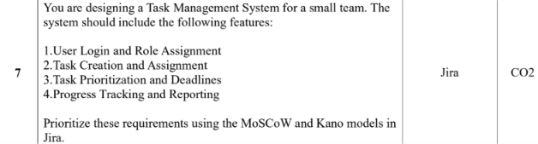

2. Objectives
- Create a Scrum project in Jira and record each requirement as a work item.
- Create the four MoSCoW priorities (Must Have, Should Have, Could Have, Won’t) in Jira.
- Assess the impact and feasibility of every requirement.
- Classify each requirement using the MoSCoW model and apply it through the Jira Priority field.
- Classify each requirement using the Kano model and apply it through Jira Labels (KANO-BASIC, KANO-PERFORMANCE).
- Plan a sprint, assign the work and track the progress on the Jira board and Summary page.

3. Basic Concepts (in Simple Words)
MoSCoW: A method to decide which features to build first. The name comes from Must, Should, Could and Won’t.
Must Have: Essential. Without it the first release does not work.
Should Have: Important and valuable, but the system can run for a short time without it.
Could Have: Nice to have. Added only if time and resources allow.
Won’t Have (for now): Not included in the current release. It may be reconsidered later.
Kano model: A method that classifies features by how they affect user satisfaction, not by how urgent they are. It asks: how will users feel if the feature is present, and how will they feel if it is missing?
Kano Category | Meaning | Jira Label Used
Basic (Must-be) | Expected by users. Missing it causes strong dissatisfaction; having it gives no extra delight. | KANO-BASIC
Performance (One-dimensional) | The better it is done, the more satisfied the users are. | KANO-PERFORMANCE
Excitement (Delighter) | Unexpected extras that delight users; no dissatisfaction if absent. | KANO-EXCITEMENT (not needed for these four requirements)

Jira terms: A work item is one requirement or task. The backlog is the list of planned work. A sprint is a short time-box in which selected work items are completed. The board shows the work items in the columns To Do, In Progress and Done. A label is a tag added to a work item.

4. Requirements
- A computer with an internet connection and a web browser.
- A Jira Software (Atlassian Cloud) account with permission to create a project and to edit priorities (Jira administrator).
- The list of 4 requirements of the Task Management System.
- Assumption: a small team working with limited time and resources, using one Scrum sprint.

5. Step-by-Step Procedure

Part A: Create the Project and Work Items
- Log in to Jira. Open your Atlassian site (for example ramprasadh.atlassian.net) and sign in. Click Jira in the top-left corner.
- Create the project. Go to Spaces > Create space, choose the Scrum template, enter the name Task Management System and the key TASK. The board is created as the TASK board.
- Open the Backlog. On the TASK board, click the Backlog tab.
- Create the four work items. Click + Create, type each title below and press Enter: TASK-1 User Login and Role Assignment, TASK-2 Task Creation and Assignment, TASK-3 Task Prioritization and Deadlines, TASK-4 Progress Tracking and Reporting. The four items appear in the backlog (Figure 1).
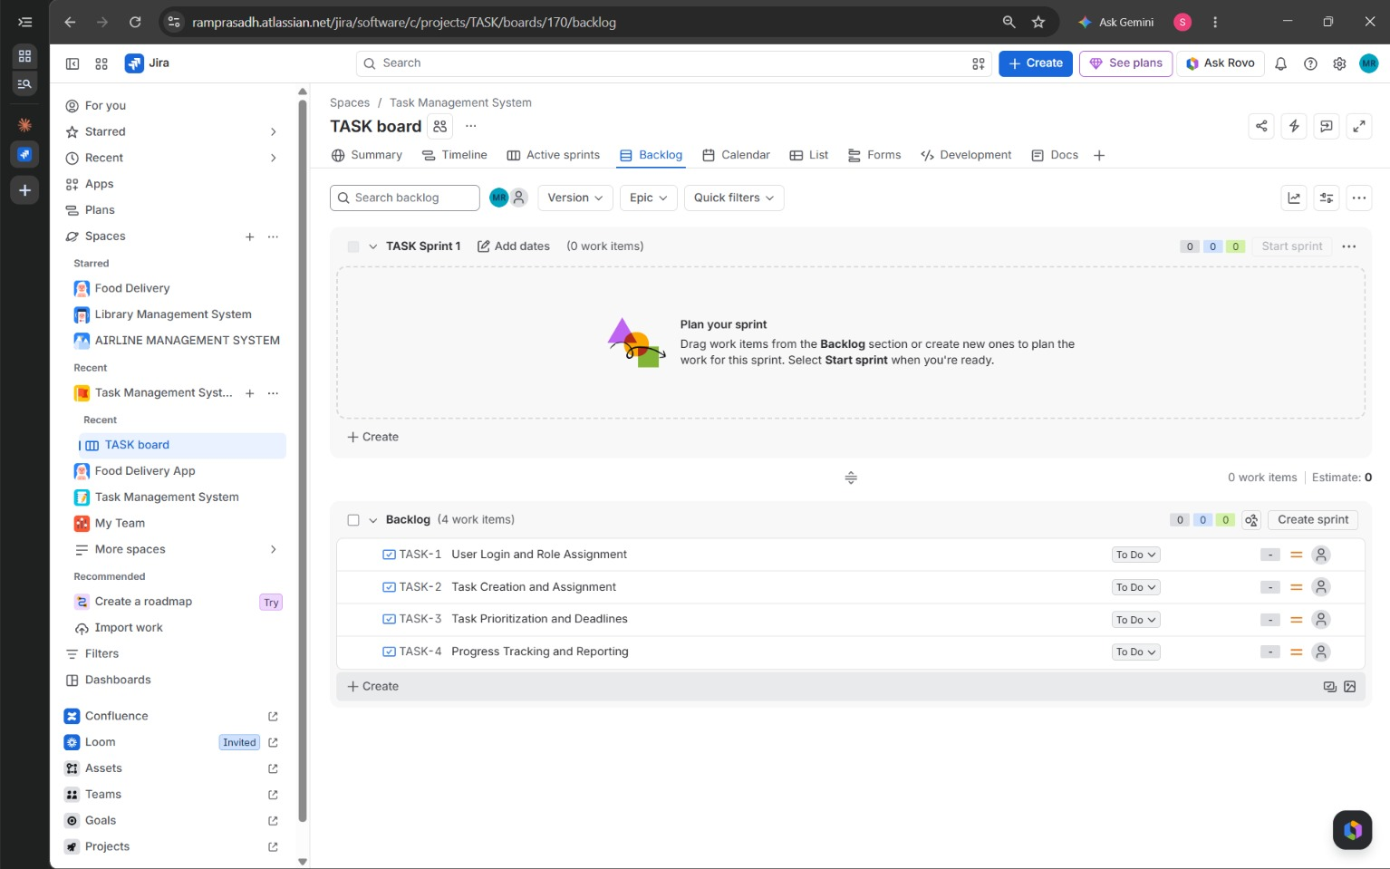
Figure 1: Four work items created in the Backlog of the TASK board (TASK Sprint 1 is still empty)

Part B: Plan and Start the Sprint
- Create the sprint. Click Create sprint. Jira creates TASK Sprint 1.
- Add the items to the sprint. Select the four work items and drag them from the Backlog section into TASK Sprint 1. The sprint now shows 4 work items (Figure 2).
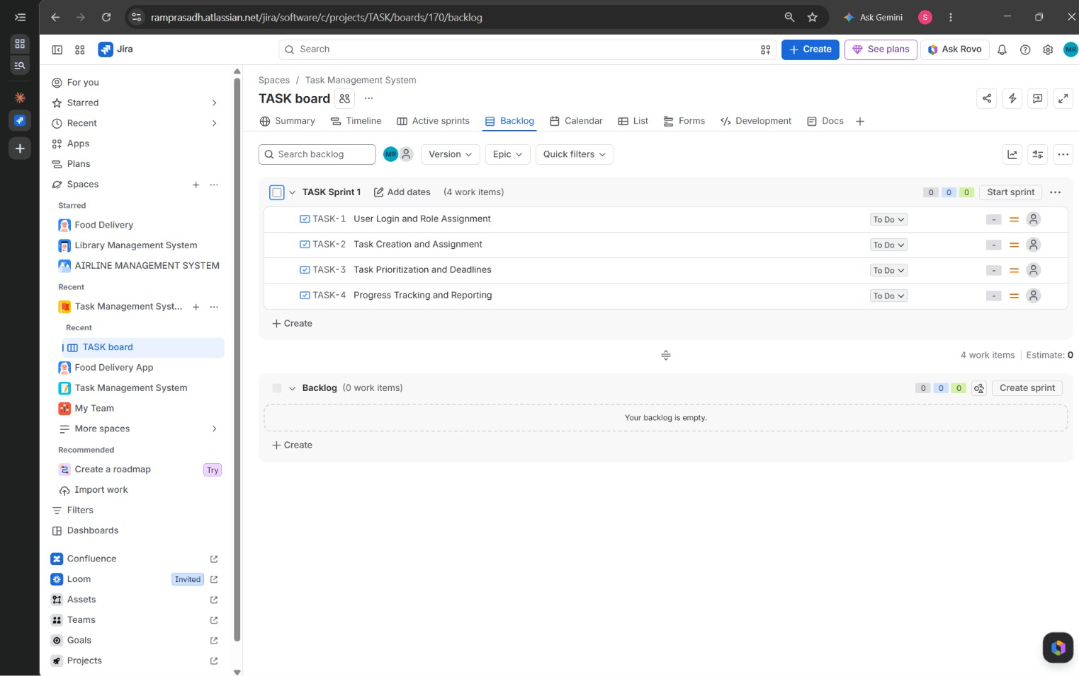
Figure 2: All four work items moved into TASK Sprint 1 before starting the sprint
- Start the sprint. Click Start sprint and confirm. Jira opens the Active sprints board with the four items in the To Do column (Figure 3).
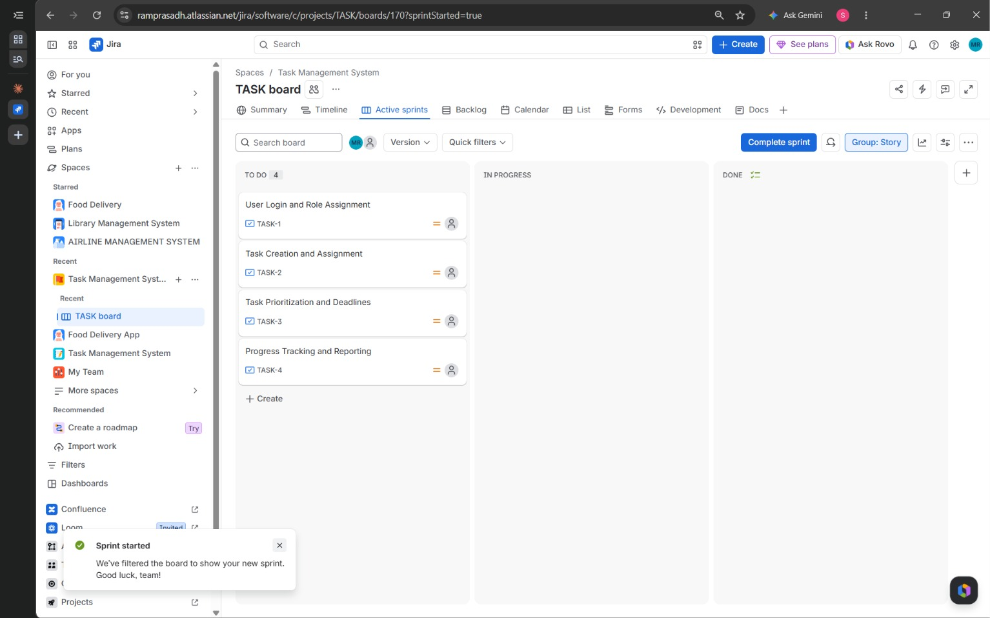
Figure 3: Sprint started: the Active sprints board with the four items in the To Do column

Part C: Add the MoSCoW Priorities in Jira
- Open the priority settings. Click the gear icon (Settings) and select Work items. In the left menu under Priorities, click Priorities.
- Add the four MoSCoW priorities. Click Add priority and create Must Have, Should Have, Could Have and Won’t. For each one choose an icon and a colour (for example dark red for Must Have) and click Save. The new priorities appear below the default Jira priorities and belong to the Default priority scheme (Figure 4).
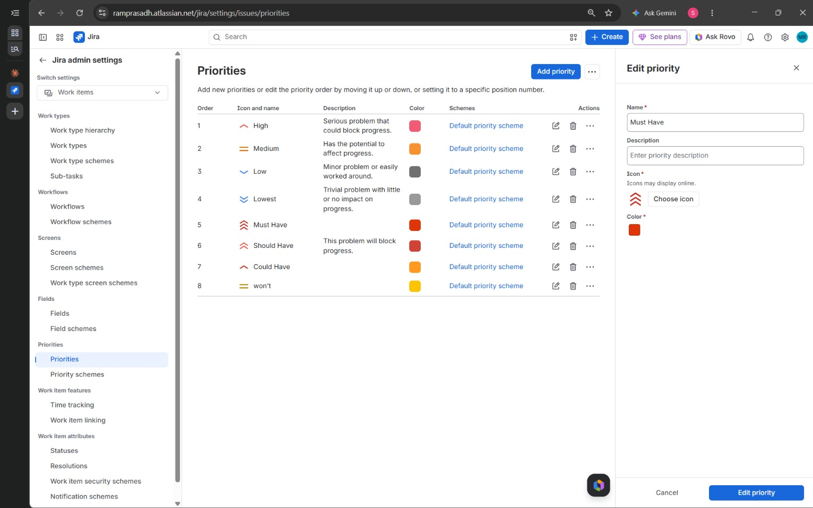
Figure 4: Jira admin settings > Priorities: MoSCoW priorities (Must Have, Should Have, Could Have, Won’t) added

Part D: Apply MoSCoW and Kano Priority schemes
- Open each work item. Click a card on the board or a row in the backlog, for example TASK-2, to open the work item details.
- Set the MoSCoW priority. In the Details panel, click the Priority field and select the category from Section 6: TASK-1 Must Have, TASK-2 Should Have, TASK-3 Should Have, TASK-4 Could Have.
- Add the Kano label. Click the Labels field, type the label and press Enter: KANO-BASIC for TASK-1 and TASK-2; KANO-PERFORMANCE for TASK-3 and TASK-4 (Figure 5).
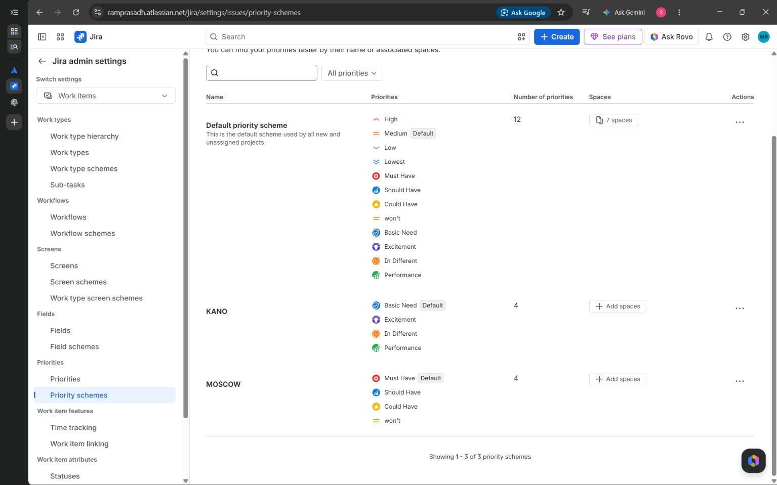
Figure 5: Work item TASK-2 showing the Should Have priority and the KANO-BASIC label
- Assign the work. Click the Assignee field and choose a team member for each work item. The Reporter is the person who created the item.

Part E: Track the Progress
- Update the status. On the Active sprints board, drag each card to In Progress when work starts and to Done when it is finished (or use the Status drop-down on the work item).
- Review in List view. Open the List tab. The columns Assignee, Reporter, Priority, Status and Labels show the MoSCoW and Kano decisions for all work items in one table (Figure 6).
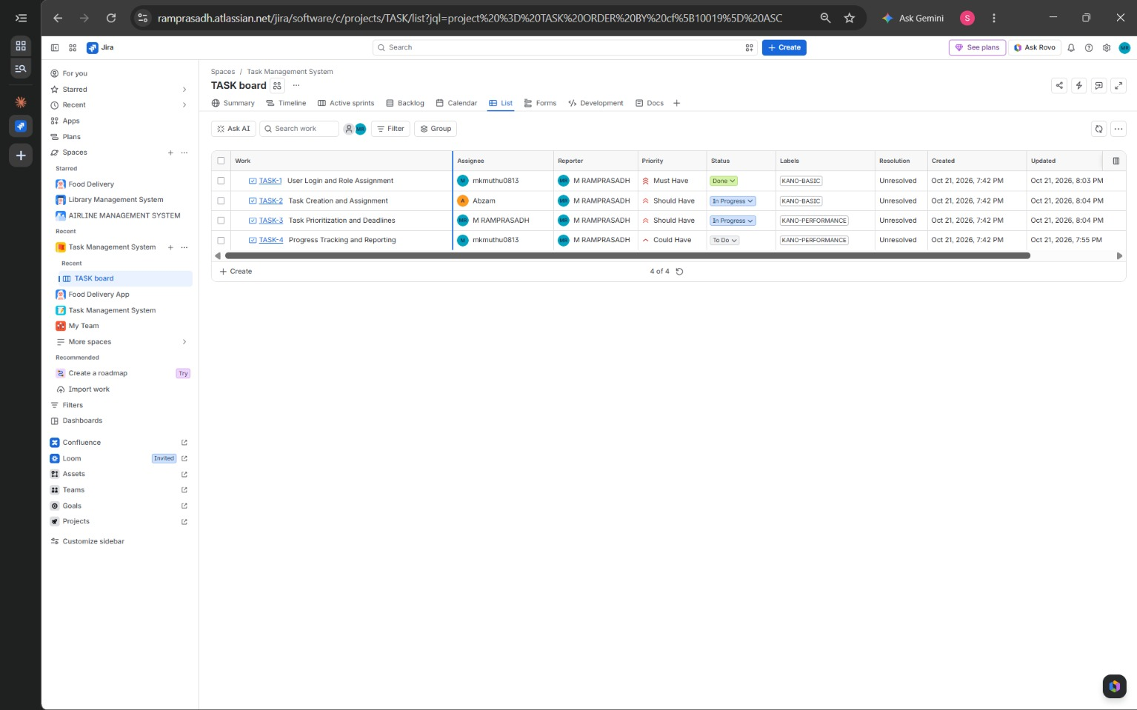
Figure 6: List view with the Priority (MoSCoW), Status and Labels (Kano) of all four work items
- Check the Summary page. Open the Summary tab to see the status overview chart, the counts of created and completed items and the recent activity (Figure 7).
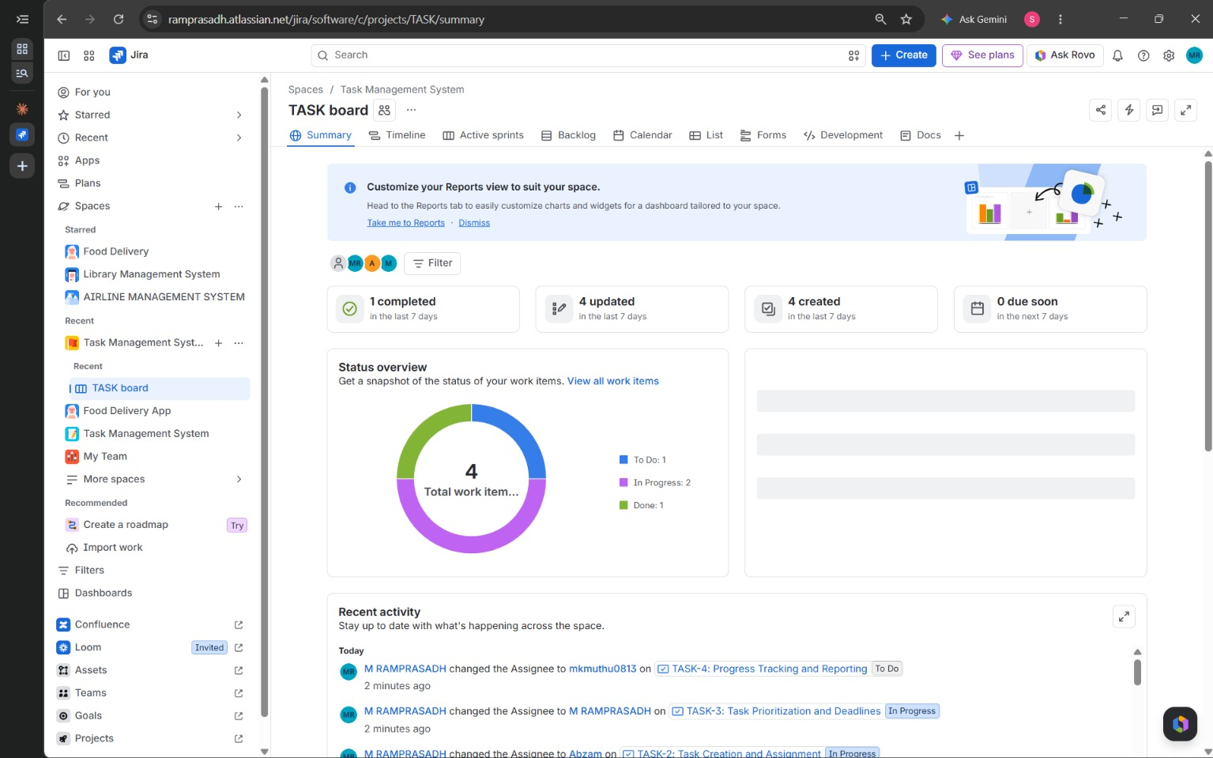
Figure 7: Summary tab showing the status overview (To Do: 1, In Progress: 2, Done: 1)

Part F: Analyse and Save
- Compare the two models. Count the items in each MoSCoW and Kano category and compare them (Section 8).
- Capture the output. Take a screenshot after each key step (Backlog, Active sprints board, Priorities page, work item, List view and Summary page) and paste it under that step, as shown in Figures 1 to 7.

6. Requirements and Their MoSCoW and Kano Classification
No. | Jira Key | Requirement | MoSCoW (Priority) | Kano (Label)
1 | TASK-1 | User Login and Role Assignment | Must Have | KANO-BASIC
2 | TASK-2 | Task Creation and Assignment | Should Have | KANO-BASIC
3 | TASK-3 | Task Prioritization and Deadlines | Should Have | KANO-PERFORMANCE
4 | TASK-4 | Progress Tracking and Reporting | Could Have | KANO-PERFORMANCE

7. Detailed Prioritization (Impact, Feasibility and Justification)
TASK-1: User Login and Role Assignment
MoSCoW category | Must Have
Kano category | Basic (Must-be) (KANO-BASIC)
Impact on users and stakeholders | Very high. Every other feature depends on knowing who the user is. Login protects the data and roles (for example Admin / Team Lead and Team Member) decide who may create, assign and view tasks.
Feasibility (time, budget, resources) | High. Standard authentication with two or three simple roles is quick to build and needs no special infrastructure.
MoSCoW justification | Without login and roles there is no working or secure system, so it is essential for the first release and has no workaround.
Kano justification | Users simply expect a login. Its absence causes strong dissatisfaction, but having it adds no extra delight, which is the nature of a Basic need.

TASK-2: Task Creation and Assignment
MoSCoW category | Should Have
Kano category | Basic (Must-be) (KANO-BASIC)
Impact on users and stakeholders | Very high for the team. Creating a task and giving it an owner is the main purpose of the system.
Feasibility (time, budget, resources) | High to medium. Needs forms, a task data model and a user picker, and depends on TASK-1 (users and roles) being available.
MoSCoW justification | Built right after login in Sprint 1. It was rated Should Have because the first version can be kept minimal (title, description and assignee only) while attachments, sub-tasks and links follow later.
Kano justification | A task tool that cannot create or assign tasks is not acceptable to users, so it is an expected Basic need even though its advanced options can be delivered later.

TASK-3: Task Prioritization and Deadlines
MoSCoW category | Should Have
Kano category | Performance (One-dimensional) (KANO-PERFORMANCE)
Impact on users and stakeholders | High. Priorities and due dates help a small team focus on urgent work and avoid missed deadlines.
Feasibility (time, budget, resources) | High to medium. Priority and due-date fields are simple, but reminders and overdue highlighting need extra rules.
MoSCoW justification | Valuable, but the team can work for a short time with an informal agreement on order, so it can follow the core task features.
Kano justification | The better the priority and deadline handling (reminders, sorting, overdue alerts), the more satisfied users are, so satisfaction grows in proportion to quality.

TASK-4: Progress Tracking and Reporting
MoSCoW category | Could Have
Kano category | Performance (One-dimensional) (KANO-PERFORMANCE)
Impact on users and stakeholders | Medium to high. Managers can see status, completed work and workload at a glance and plan better.
Feasibility (time, budget, resources) | Medium. Charts and reports need clean data from the earlier features and extra design and testing effort.
MoSCoW justification | A small team can check the board manually in the beginning, so reporting is an upgrade that can be added if time and resources allow.
Kano justification | More complete and accurate reports give proportionally more satisfaction, which is typical of a Performance need.

8. Observation
Work items created in Jira and their final status
Key | Summary | Assignee | Priority | Status | Label
TASK-1 | User Login and Role Assignment | mkmuthu0813 | Must Have | Done | KANO-BASIC
TASK-2 | Task Creation and Assignment | Abzam | Should Have | In Progress | KANO-BASIC
TASK-3 | Task Prioritization and Deadlines | M RAMPRASADH | Should Have | In Progress | KANO-PERFORMANCE
TASK-4 | Progress Tracking and Reporting | mkmuthu0813 | Could Have | To Do | KANO-PERFORMANCE

MoSCoW and Kano count
Category | Count | Requirements
Must Have | 1 | User Login and Role Assignment
Should Have | 2 | Task Creation and Assignment; Task Prioritization and Deadlines
Could Have | 1 | Progress Tracking and Reporting
Won’t Have | 0 | None (the priority was created in Jira but not needed for these four requirements)
Kano: Basic | 2 | User Login and Role Assignment; Task Creation and Assignment
Kano: Performance | 2 | Task Prioritization and Deadlines; Progress Tracking and Reporting
Kano: Excitement | 0 | None
Total requirements | 4 | Each requirement has one MoSCoW priority and one Kano label.

The Summary page of the board shows 4 work items in total: 1 in To Do, 2 in In Progress and 1 in Done, so 1 item was completed within the sprint.
Both models agree on the foundation: User Login and Role Assignment is a Must Have and a Basic need. Task Creation and Assignment is also a Basic need, but it is rated Should Have because MoSCoW looks at delivery order, effort and workarounds, while Kano looks at what users expect. The two Performance features (Prioritization and Deadlines, Progress Tracking and Reporting) are the ones where extra effort gives extra satisfaction, so they are the best candidates for improvement in later sprints. No Excitement (delighter) feature was identified among the four requirements.

9. Result
The four requirements of the Task Management System were prioritized in Jira using the MoSCoW and Kano models. Using the Priority field, 1 requirement was classified as Must Have, 2 as Should Have, 1 as Could Have and none as Won’t Have. Using Labels, 2 were classified as KANO-BASIC and 2 as KANO-PERFORMANCE. The requirements were planned in TASK Sprint 1, assigned to team members and tracked on the board, List view and Summary page.

10. Conclusion
This experiment showed how Jira can be used to prioritize requirements in practice. MoSCoW, applied through custom priorities, tells the team what to build first, while Kano, applied through labels, explains how each feature affects user satisfaction. Using both together gives a balanced plan: Basic needs such as login and task creation are delivered first to make the system usable, and Performance features such as deadlines and reporting are improved afterwards to increase satisfaction. Tracking the work on the sprint board and Summary page also gave the team a clear, live view of progress.

